

DATA SCIENCE LAB RECORD

(20MCA241)

ASHA S S3RMCA-A

Roll No:26

Date:24/11/2021

# Program - 1

## Aim:

Perform all matrix operations using python (using numpy).

## Program:

import numpy x=numpy.array([[2,4],[7,5]])

y=numpy.array([[5,6],[4,7]]) print("Matrix Addition") print(numpy.add(x,y)) print("Matrix Subraction") print(numpy.subtract(x,y)) print("Matrix multiplication") print(numpy.multiply(x,y)) print("Matrix product") print(numpy.dot(x,y)) print("Matrix square root") print(numpy.sqrt(x)) print("Matrix divison") print(numpy.divide(x,y)) print("Matrix sum of element") print(numpy.sum(x))

print("Matrix sum of elements (x-axis)") print(numpy.sum(x,axis=0))

print("Matrix Transpose of x") print(x.T)

**OUTPUT**

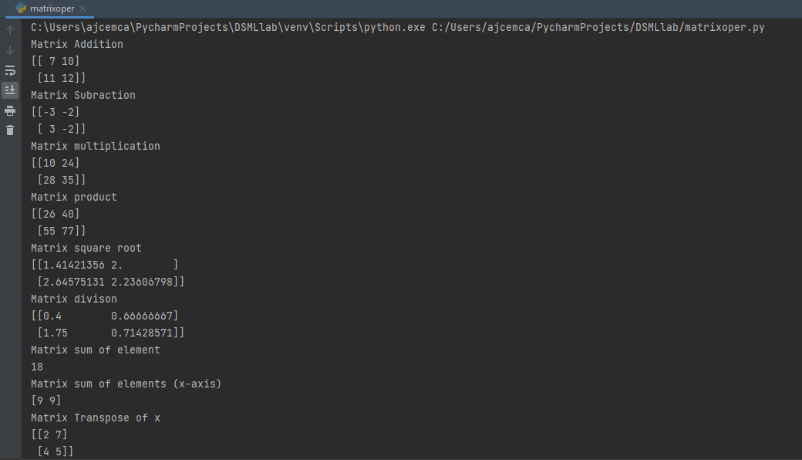

# Program - 2

Date:01/12/2021



## Aim:

Perform SVD(Singular Value Decomposition)

## Program:

from numpy import array from scipy.linalg import svd

a=array([[1,2,3,4],[7,8,3,5],[4,6,9,10]])

print(a) u,s,vt=svd(a)

print("Decomposed Matrix\n",u) print("Inverse Matrix\n",s) print("Transpose matrix\n",vt)

**OUTPUT**

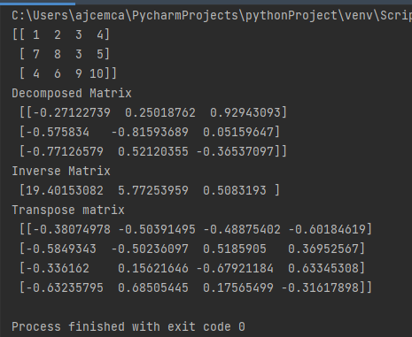

# Program - 3

## Aim:

Program to implement k-NN classification using any standard dataset available in the public domain and find the accuracy of the algorithm

## Program:

from sklearn.neighbors import KNeighborsClassifier from sklearn.model_selection import train_test_split from sklearn.datasets import load_iris

from sklearn.metrics import accuracy_score

idata=load_iris() x=idata.data y=idata.target

x_train,x_test,y_train,y_test=train_test_split( x,y,test_size=0.3,random_state=55) knn=KNeighborsClassifier(n_neighbors=3)

knn.fit(x_train,y_train) y_p=knn.predict(x_test) print(knn.predict(x_test))

print(“Accuracy score : ”,accuracy_score(y_test,y_p))

**OUTPUT**

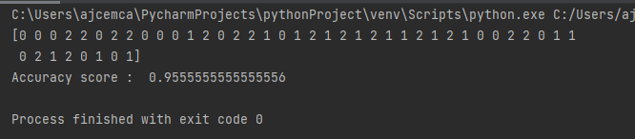

# Program - 4

## Aim:

Program to implement k-NN classification using any random data set without using inbuilt packages.

## Program:

from math import sqrt def e_dis(r1,r2):

dist=0.0

for i in range(len(r1)-1): dist+=(r1[i]-r2[i])**2

return sqrt(dist)

def get_ne(train,test_row,num_neig): distances=list()

for train_row in train: dist=e_dis(test_row,train_row) distances.append([test_row,train_row])

distances.sort(key=lambda tup:tup[1]) neighbors=list()

for i in range(num_neig): neighbors.append(distances[i][0])

return neighbors

def predict_classif(train,test_row,num_neig): neighbors = get_ne(train,test_row,num_neig) out_val=[row[-1] for row in neighbors]

prediction=max(set(out_val),key=out_val.count) return prediction

dataset=[[2.734,2.55,0],

[1.45,3.36,0],

[2.334, 2.355, 0],

[1.45, 3.36, 0],

[2.334, 2.55, 0],

[1.45, 3.336, 0],

[3.334, 3.55, 1],

[1.45, 3.36, 1],

[3.734, 4.55, 1],

[3.45, 4.36, 1],

[4.734, 5.55, 1],

[3.45, 5.36, 1]]

prediction=predict_classif(dataset,dataset[0],3) print('Excpected %d,Got %d'%(dataset[0][-1],prediction))

**OUTPUT**

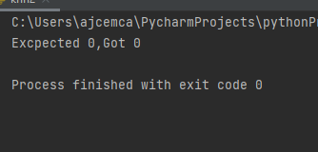

# Program - 5

Date:08/12/2021



## Aim:

Program to implement Naïve Bayes Algorithm using any standard dataset available in the public domain and find the accuracy of the algorithm

## Program:

import pandas as pd

from sklearn.model_selection import train_test_split from sklearn.preprocessing import StandardScaler from sklearn.naive_bayes import GaussianNB

from sklearn.metrics import confusion_matrix,accuracy_score

dataset=pd.read_csv('Social_Network_Ads.csv') x=dataset.iloc[:,[2,3]].values

y=dataset.iloc[:,-1].values x_train,x_test,y_train,y_test=train_test_split(x,y,test_size=0.30)

sc=StandardScaler() x_train=sc.fit_transform(x_train) x_test=sc.transform(x_test)

classifier=GaussianNB() classifier.fit(x_train,y_train)

y_pred=classifier.predict(x_test) print(y_pred)

ac = accuracy_score(y_test,y_pred) print(ac)

**OUTPUT**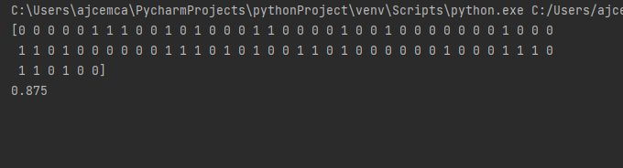

# Program - 6

## Aim:

Program to implement linear regression techniques using any standard dataset available in the public domain and evaluate its performance.

## Program(inbuilt):

import numpy as np

import matplotlib.pyplot as plt

from sklearn.linear_model import LinearRegression x=np.array([5,15,25,35,45,55]).reshape((-1,1)) y=np.array([5,20,14,32,22,38])

print(x) print(y)

model=LinearRegression() model.fit(x,y) r_sq=model.score(x,y)

print('coefficent of determination: ',r_sq) print('intercept: ',model.intercept_) print('slope : ',model.coef_) y_pred=model.predict(x) print('Predicted response: ',y_pred) plt.scatter(x,y,color="g") plt.plot(x,y_pred)

plt.xlabel('x')

plt.ylabel('y')

plt.show()

**OUTPUT**

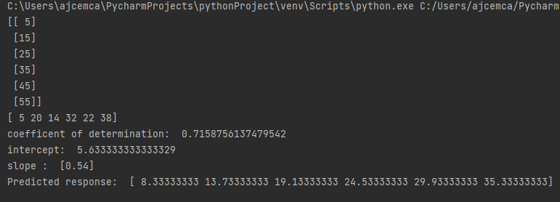

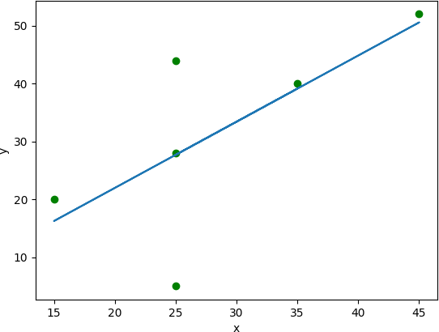

## Program:7 (Without inbuilt):

### Aim:

Program to implement linear regression techniques using any standard dataset available in the public domain and evaluate its performance.

**Program:**

import numpy as np

import matplotlib.pyplot as plt def estimate_coef(x,y):

n=np.size(x) m_x=np.mean(x) m_y=np.mean(y)

SS_xy=np.sum(y*x) - n *m_y* m_x SS_xx=np.sum(x*x) - n *m_x* m_x b_1=SS_xy / SS_xx

b_0=m_y - b_1* m_x return (b_0,b_1)

def plot_regr_line(x,y,b): plt.scatter(x,y,color="m",marker="o",s=30) y_pred=b[0]+b[1]*x plt.plot(x,y_pred,color="g")

plt.xlabel('x')

plt.ylabel('y') plt.show()

def main():

x = np.array([0, 1, 2, 3, 4, 5, 6, 7, 8, 9])

y = np.array([1, 3, 2, 5, 7, 8, 8, 9, 10, 12])

b = estimate_coef(x, y)

print("Estimated coefficients:\nb_0 = {} \

\nb_1 = {}".format(b[0], b[1])) plot_regr_line(x, y, b)

if name ==" main ": main()

**OUTPUT**

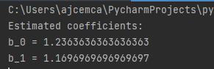

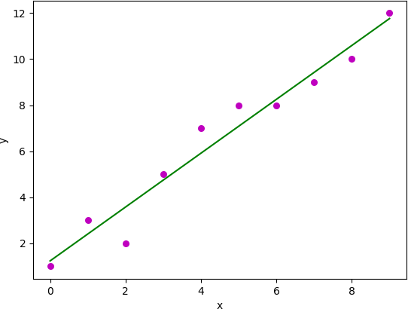

# Program - 8

Date:15-12-2021



## Aim:

Program to implement multiple regression techniques using any standard dataset available in the public domain and evaluate its performance.

**Program:**

import pandas df=pandas.read_csv("cars.csv") x=df[['Weight','Volume']] y=df['CO2']

from sklearn import linear_model regr=linear_model.LinearRegression() regr.fit(x,y) predictedco2=regr.predict([[2300,1300]]) print(predictedco2)

**OUTPUT**

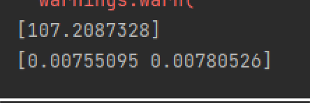

# Program - 9

Date:15-12-2021



## Aim:

Program to implement multiple regression techniques using any standard dataset available in the public domain and evaluate its performance.

import matplotlib.pyplot as plt

from sklearn import datasets,linear_model,metrics

boston=datasets.load_boston()

x=boston.data y=boston.target

from sklearn.model_selection import train_test_split x_train,x_test,y_train,y_test=train_test_split( x,y,test_size=0.4,random_state=1)

reg=linear_model.LinearRegression() reg.fit(x_train,y_train)

pre=reg.predict(x_test) print("Prediction : ",pre) print('Coefficients: ',reg.coef_)

print('Variance Score:{}'.format(reg.score(x_test,y_test)))

**OUTPUT**



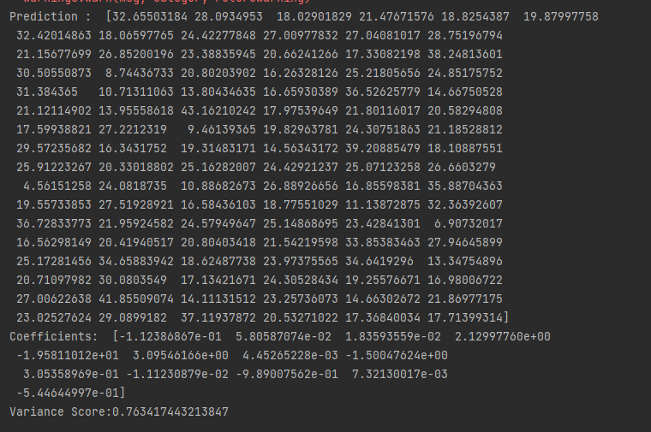

# Program - 10

Date:22-12-2021



## Aim:

Program to implement decision trees using any standard dataset available in the public domain and find the accuracy of the algorithm

### Program:

import pandas as pd import numpy as np import seaborn as sns

import matplotlib.pyplot as plt

from sklearn.preprocessing import LabelEncoder from sklearn.model_selection import train_test_split

from sklearn.tree import DecisionTreeClassifier

from sklearn.metrics import classification_report,confusion_matrix

from sklearn.tree import plot_tree df=sns.load_dataset('iris') print(df.head())

print(df.info())

df.isnull().any() print(df.shape)

sns.pairplot(data=df,hue='species')

plt.savefig("pne.png")

sns.heatmap(df.corr()) plt.savefig("one.png") target=df['species'] df1=df.copy() df1=df1.drop('species',axis=1) print(df1.shape) print(df1.head())

x=df1 print(target)

le=LabelEncoder() target=le.fit_transform(target) print(target)

y=target

x_train,x_test,y_train,y_test=train_test_split(x,y,test_size=0.2,random_state=42)

print("Training split input",x_train.shape) print("Testing split input",x_test.shape)

dtree=DecisionTreeClassifier()

dtree.fit(x_train,y_train)

print("Decision tree classifier created")

y_pred=dtree.predict(x_test)

print("classsification report \n",classification_report(y_test,y_pred)) cm=confusion_matrix(y_test,y_pred)

plt.figure(figsize=(5,5))

sns.heatmap(data=cm,linewidth=5,annot=True,square=True,cmap='Blues')

plt.ylabel('Actual label') plt.xlabel('Predictd label')

all_sample_title='Accuracy Score:{0}'.format(dtree.score(x_test,y_test))

plt.savefig("two.png")

plt.figure(figsize=(20,20)) dec_tree=plot_tree(decision_tree=dtree,feature_names=df1.columns,

class_names=["setosa","vercicikor","verginica"],filled=True,precision=4,rounded=True) plt.savefig("three.png")

**OUTPUT**



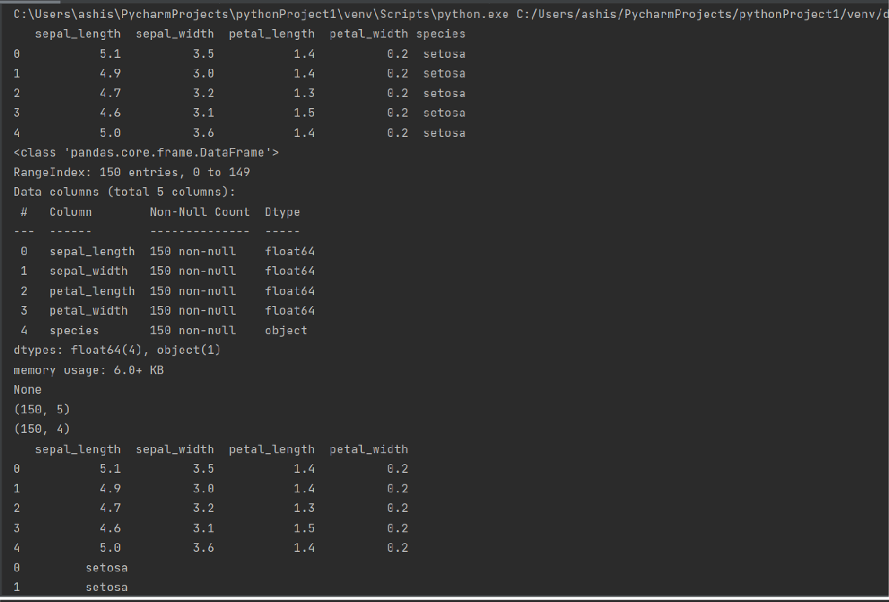

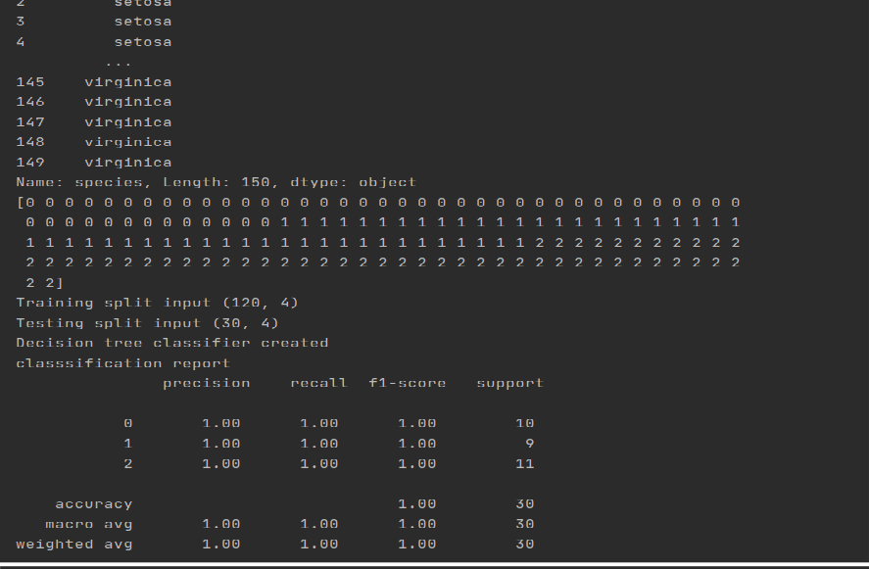

**Pne.png**



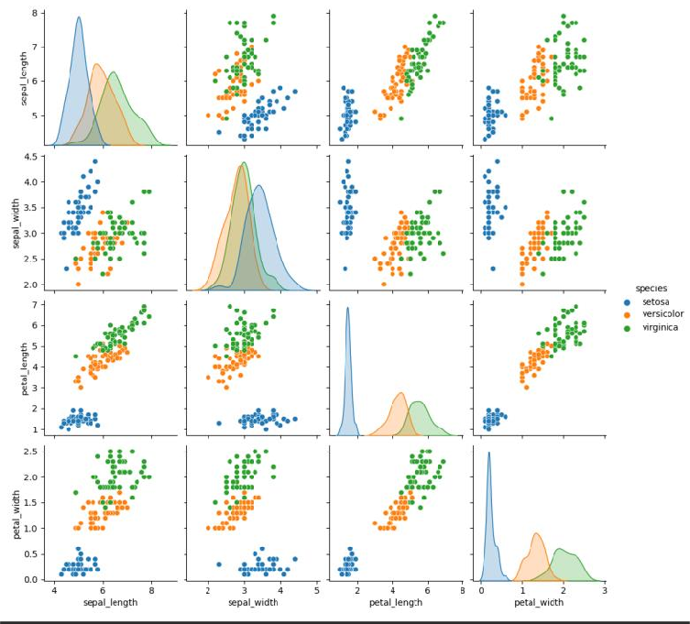

**One.png**

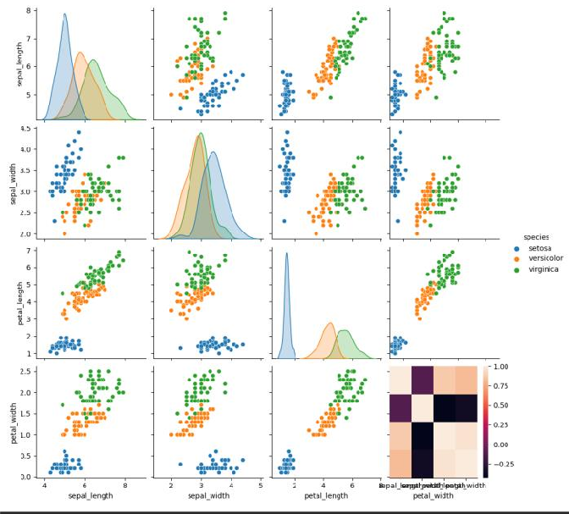

**Two.png**



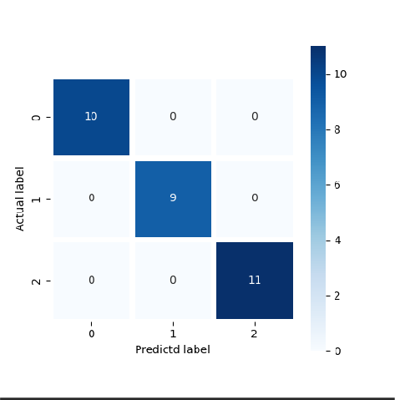

**Three.png**

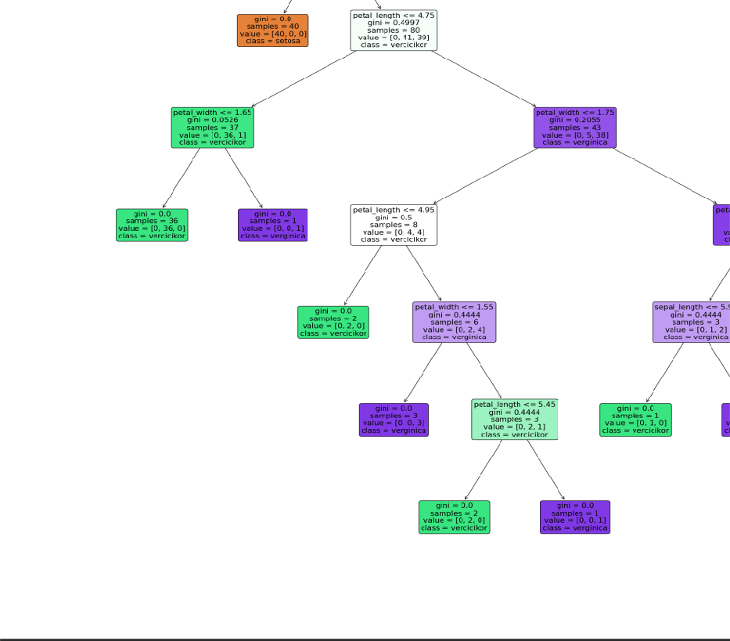

# Program - 11

Date:05-01-2022



## Aim:

Program to implement k-means clustering technique using any standard dataset available in the public domain

**Program:**

import numpy as nm

import matplotlib.pyplot as mtp import pandas as pd

dataset = pd.read_csv('Mall_Customers.csv') x=dataset.iloc[:,[3,4]].values

print(x)

from sklearn.cluster import KMeans wcss_list=[]

for i in range(1,11):

kmeans=KMeans(n_clusters=i,init='k-means++',random_state=42) kmeans.fit(x)

wcss_list.append(kmeans.inertia_) mtp.plot(range(1,11),wcss_list) mtp.title('The Elbow Method Graph') mtp.xlabel('Number of clusters(k)') mtp.ylabel('wcss_list')

mtp.show()

kmeans=KMeans(n_clusters=5,init='k-means++',random_state=42) y_predict=kmeans.fit_predict(x)

print(y_predict)

mtp.scatter(x[y_predict ==0,0],x[y_predict ==0,1],s=100,c='blue',label='cluster 1') mtp.scatter(x[y_predict ==1,0],x[y_predict ==1,1],s=100,c='green',label='cluster 2') mtp.scatter(x[y_predict ==2,0],x[y_predict ==2,1],s=100,c='red',label='cluster 3') mtp.scatter(x[y_predict ==3,0],x[y_predict ==3,1],s=100,c='cyan',label='cluster 4') mtp.scatter(x[y_predict ==4,0],x[y_predict ==4,1],s=100,c='magenta',label='cluster 5') mtp.scatter(kmeans.cluster_centers_[:,0],kmeans.cluster_centers_[:,1],s=300,c='black',label='cluster') mtp.title('Clusters of customers')

mtp.xlabel('Annual Income (K$)') mtp.ylabel('Spending Score(1-100)') mtp.legend()

mtp.show()

**OUTPUT**



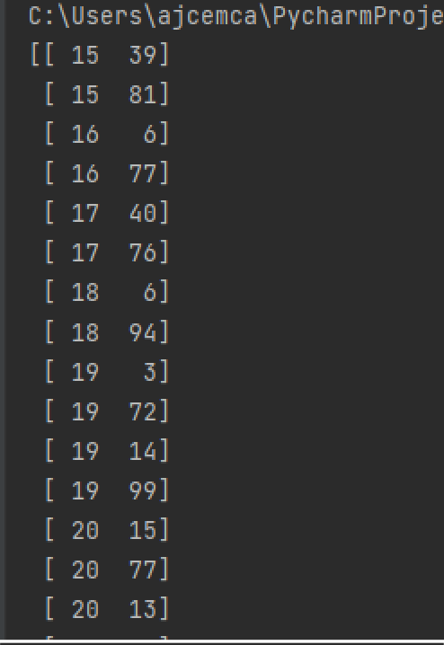

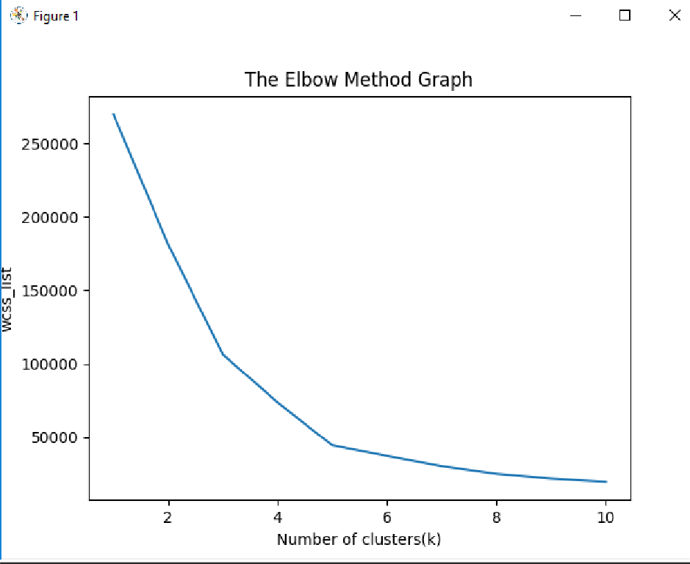



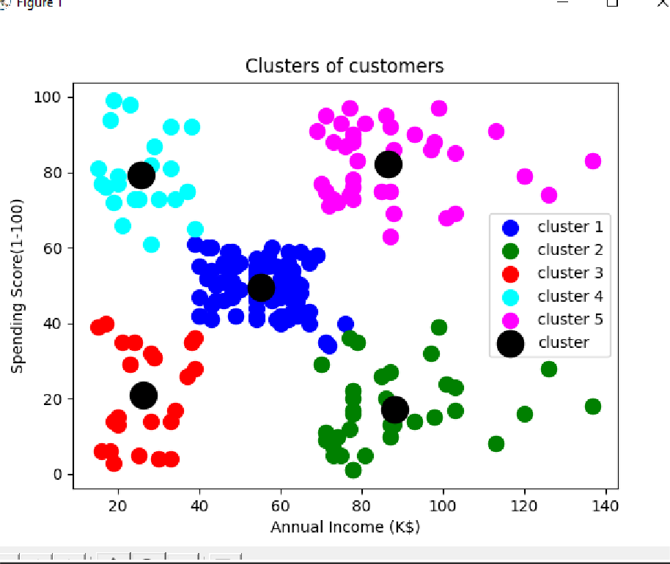

# Program - 12

Date:05-01-2022



## Aim:

Program to implement k-means clustering technique using any standard dataset available in the public domain (Using world_country_and_usa_states_latitude_and_longitude_values.csv)

**PROGRAM**

import numpy as nm

import matplotlib.pyplot as mtp import pandas as pd

dataset = pd.read_csv('world_country_and_usa_states_latitude_and_longitude_values.csv') x=dataset.iloc[:,[1,2]].values

print(x)

from sklearn.cluster import KMeans wcss_list=[]

for i in range(1,11):

kmeans=KMeans(n_clusters=i,init='k-means++',random_state=42) kmeans.fit(x)

wcss_list.append(kmeans.inertia_) mtp.plot(range(1,11),wcss_list) mtp.title('The Elbow Method Graph') mtp.xlabel('Number of clusters(k)') mtp.ylabel('wcss_list')

mtp.show()

kmeans=KMeans(n_clusters=3,init='k-means++',random_state=42) y_predict=kmeans.fit_predict(x)

print(y_predict)

mtp.scatter(x[y_predict ==0,0],x[y_predict ==0,1],s=100,c='blue',label='cluster 1') mtp.scatter(x[y_predict ==1,0],x[y_predict ==1,1],s=100,c='green',label='cluster 2') mtp.scatter(x[y_predict ==2,0],x[y_predict ==2,1],s=100,c='red',label='cluster 3') mtp.scatter(kmeans.cluster_centers_[:,0],kmeans.cluster_centers_[:,1],s=300,c='black',label='cluster') mtp.title('Clusters of customers')

mtp.xlabel('Annual Income (K$)') mtp.ylabel('Spending Score(1-100)') mtp.legend()

mtp.show()

**OUTPUT**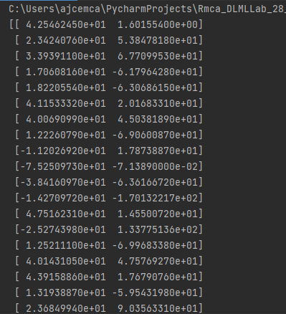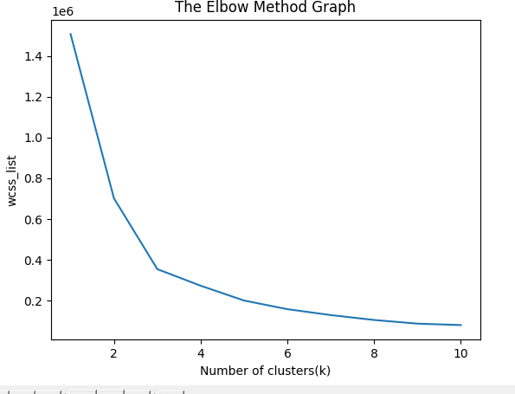



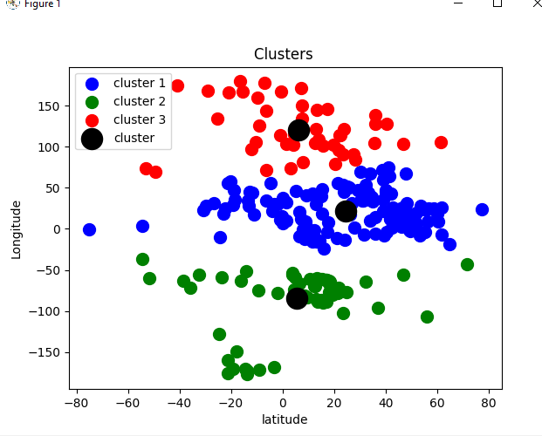

# Program – 13

# AIM: PROGRAMS ON FEEDFORWARD NETWORK TO CLASSIFY ANY STANDARD DATASET AVAILABLE IN THE PUBLIC DOMAIN

**PROGRAM**

# from tensorflow import keras

# print('Tensorflow/keras : %s'%keras.version)

# from keras.models import Sequential

# from keras import Input

# from keras.layers import Dense

# import pandas as pd

# print('pandas : %s' %pd.version)

# import numpy as np

# print('numpy : %s' %np.version)

# import sklearn

# print('sklearn : %s' %sklearn.version)

# from sklearn.model_selection import train_test_split

# from sklearn.metrics import classification_report

# import plotly

# import plotly.express as px

# import plotly.graph_objects as go

# print('plotly : %s' %plotly.version)

# pd.options.display.max_columns=50

# df=pd.read_csv('weatherAUS.csv', encoding='utf-8')

# df=df[pd.isnull(df['RainTomorrow'])==False]

# #df=df.fillna(df.mean())

# df['RainTodayFlag']=df['RainToday'].apply(lambda x: 1 if x=='Yes' else 0)

# df['RainTomorrowFlag']=df['RainTomorrow'].apply(lambda x: 1 if x=='Yes' else 0)

# print(df)

# X = df[['Humidity3pm']]

# Y = df['RainTomorrowFlag'].values

# X_train, X_test, Y_train, Y_test = train_test_split(X,Y, test_size=0.2, random_state=0)

# model = Sequential(name="Model-with-One-Input")

# model.add(Input(shape=(1,), name='Input-Layer'))

# model.add(Dense(2, activation='softplus', name='Hidden-Layer'))

# model.add(Dense(1, activation='sigmoid', name='Output-Layer'))

**OUTPUT**

# 

# 

# 

# Date:02-02-2022

# Program – 14

# AIM: PROGRAMS ON CONVOLUTIONAL NEURAL NETWORK TO CLASSIFY

# IMAGES FROM ANY STANDARD DATASET IN THE PUBLIC DOMAIN.

**PROGRAM**

import numpy as np

import pandas as pd

import matplotlib.pyplot as plt

import tensorflow as tf

from tensorflow import keras

np.random.seed(42)

# tf.set.random. seed(42)

fashion_mnist = keras.datasets.fashion_mnist

(X_train, y_train), (X_test, y_test) = fashion_mnist.load_data()

print(X_train.shape, X_test.shape)

X_train = X_train / 255.0

X_test = X_test / 255.0

plt.imshow(X_train[1], cmap='binary')

plt.show()

np.unique(y_test)

class_names = ['T-Shirt/Top', 'Trouser', 'Pullover', 'Dress', 'Coat', 'Sandal', 'Shirt', 'Sneaker', '8ag', 'Ankle Boot']

n_rows = 5

n_cols = 10

plt.figure(figsize=(n_cols * 1.4, n_rows * 1.6))

for row in range(n_rows):

for col in range(n_cols):

index = n_cols * row + col

plt.subplot(n_rows, n_cols, index + 1)

plt.imshow(X_train[index], cmap='binary', interpolation='nearest')

plt.axis('off')

plt.title(class_names[y_train[index]])

plt.show()

model_CNN = keras.models.Sequential()

model_CNN.add(keras.layers.Conv2D(filters=32, kernel_size=7, padding='same', activation='relu', input_shape=[28, 28, 1]))

model_CNN.add(keras.layers.MaxPooling2D(pool_size=2))

model_CNN.add(keras.layers.Conv2D(filters=64, kernel_size=3, padding='same', activation='relu'))

model_CNN.add(keras.layers.MaxPooling2D(pool_size=2))

model_CNN.add(keras.layers.Conv2D(filters=32, kernel_size=3, padding='same', activation='relu'))

model_CNN.add(keras.layers.MaxPooling2D(pool_size=2))

model_CNN.summary()

model_CNN.add(keras.layers.Flatten())

model_CNN.add(keras.layers.Dense(units=128, activation='relu'))

model_CNN.add(keras.layers.Dense(units=64, activation='relu'))

model_CNN.add(keras.layers.Dense(units=10, activation='softmax'))

model_CNN.summary()

model_CNN.compile(loss='sparse_categorical_crossentropy', optimizer='adam', metrics=['accuracy'])

X_train = X_train[..., np.newaxis]

X_test = X_test[..., np.newaxis]

history_CNN = model_CNN.fit(X_train, y_train, epochs=2, validation_split=0.1)

pd.DataFrame(history_CNN.history).plot()

plt.grid(True)

plt.xlabel('epochs')

plt.ylabel('loss/accuracy')

plt.title('Training and validation plot')

plt.show()

test_loss, test_accuracy = model_CNN.evaluate(X_test, y_test)

print(' Test Loss :{}, Test Accuracy : {}'.format(test_loss, test_accuracy))

**output**

